Factory Resetting a Palo Alto 220 Firewall

Purpose: The purpose of this lab was to remove a previous existing configuration and password. This allows us to buy used routers and to setup of our own configurations.

Background Information: The firewalls we got were already configured with password which prevented us from logging in. So, we need a way to remove this past password.

Lab Summary: We were able to boot the firewall into maintenance mode. This allowed us to factory reset the firewall. So, when we rebooted it had no previous configuration. This enabled us to set up own password and configuration onto the firewall.

Config: 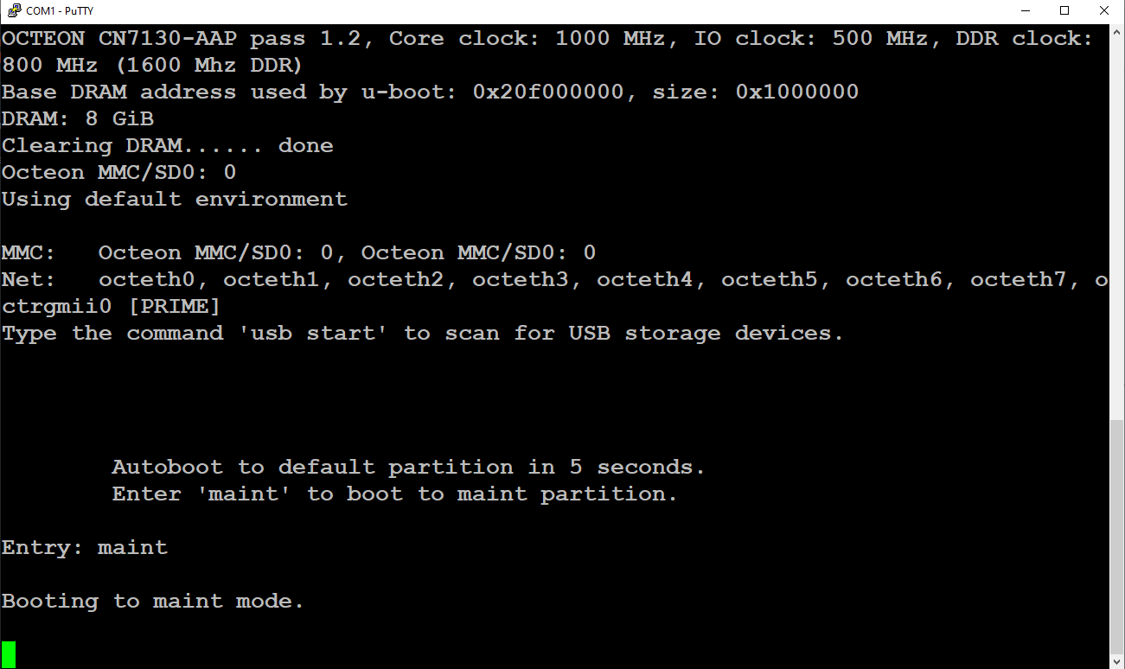

When booting firewall for first time type “maint” to enter maint mode

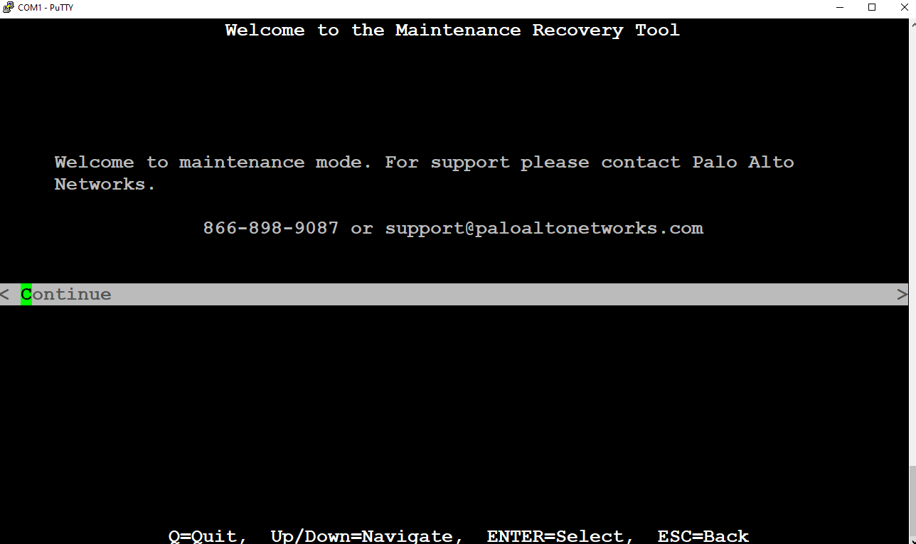

Press Continue

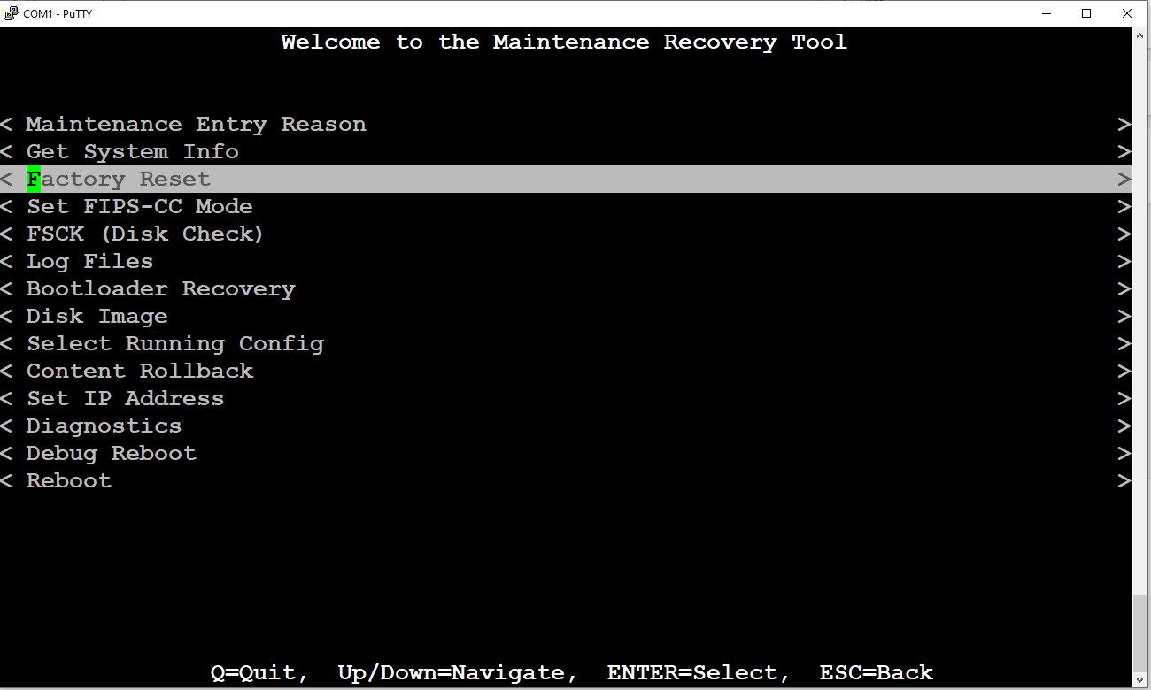

Select the Factory Reset option

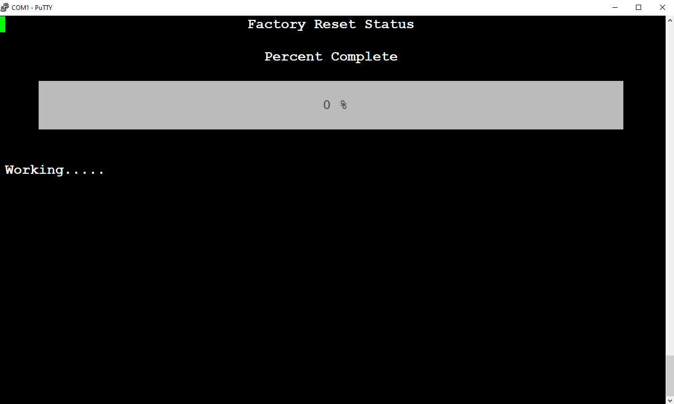

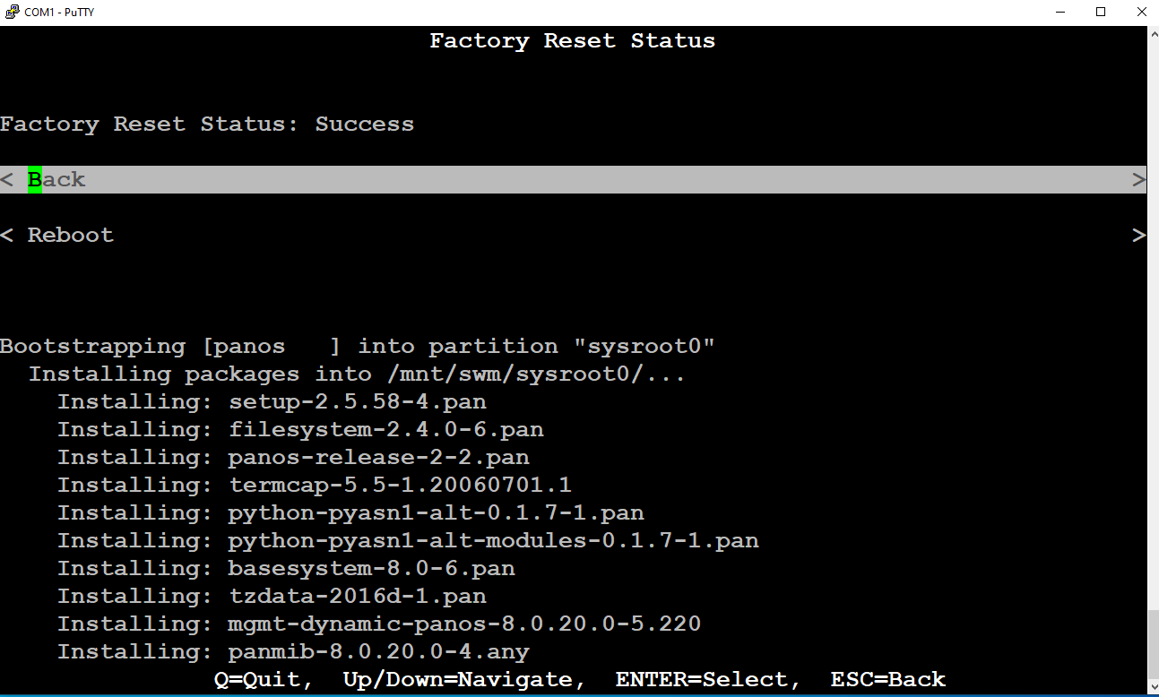

Says Reset was a success

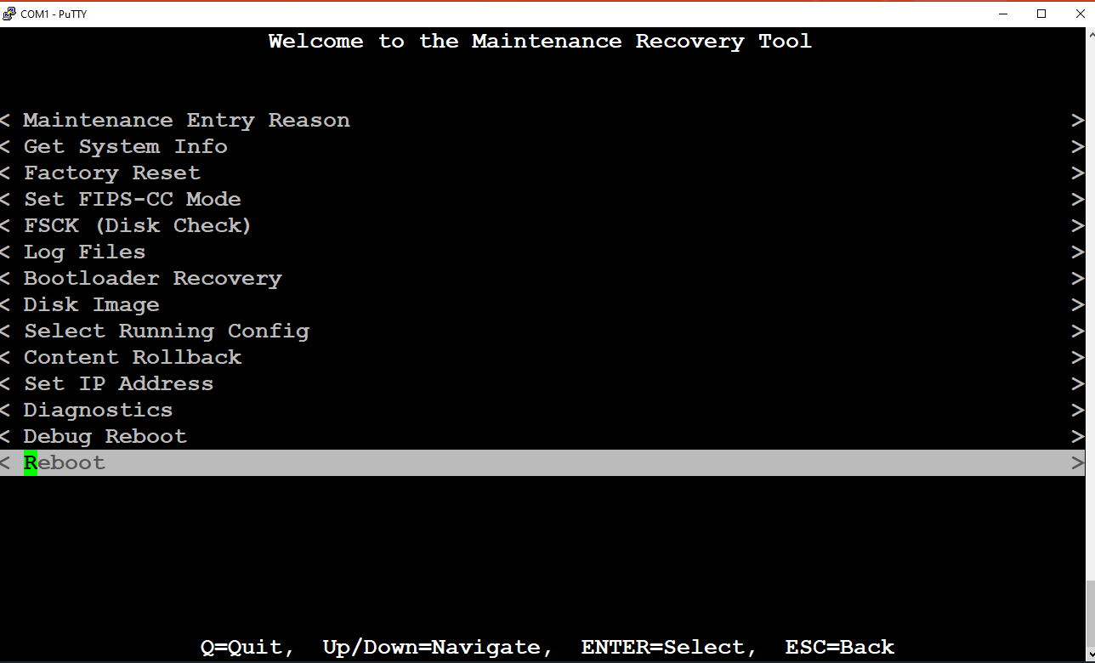

Then Reboot

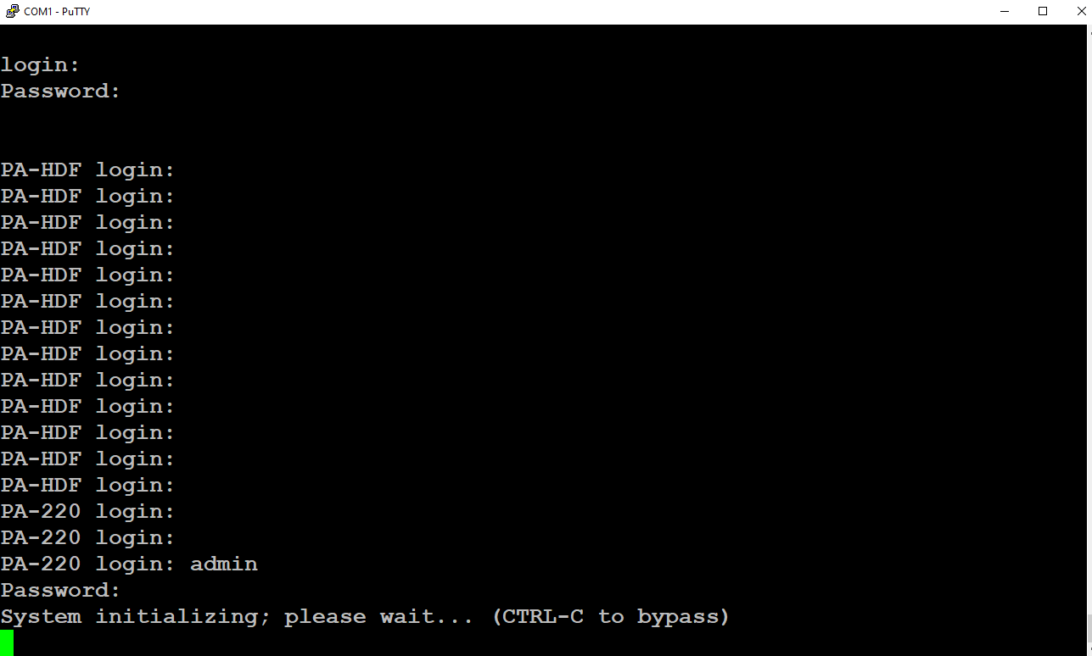Wait until it shows PA-220 prompt

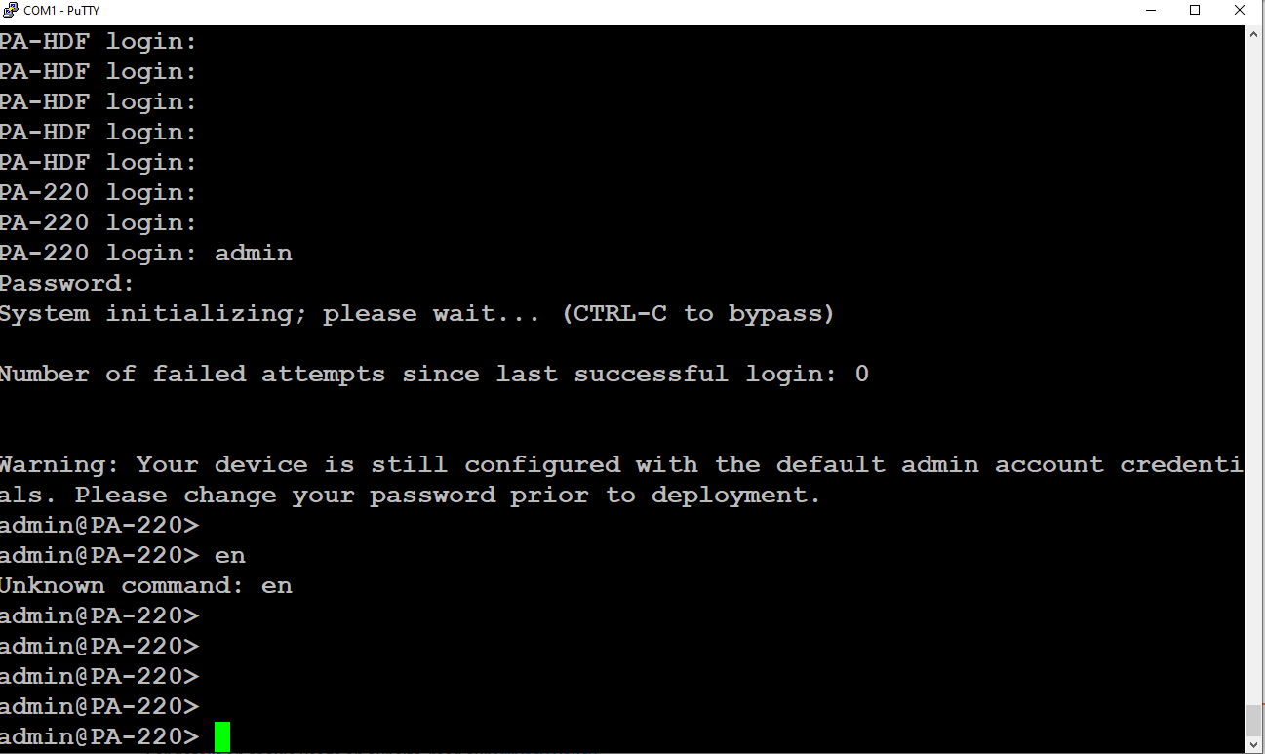enter login admin with password admin

Problems: When rebooting the firewall, we missed typing in “maint” fast enough. This took us multiple tries rebooting and thus wasted lots of our time. Once the firewall was factory reset, we tried logging in with the PA-HDF prompt but that didn’t work. We had to wait until the prompt read admin@PA-220 until we could start typing in commands.

Conclusion: In the end we learned how to successfully remove a pervious configuration from a firewall. So, we could start to put our configuration on. This is useful if we get a used firewall or need to reset one of our own.